**Case Study on Airbags**

**Problem-**

Now a days there are a large number of cars and vehicles are there in on roads. So the chances of accidents also increases. This may lead to head injuries and major injuries.

**Requirements-**

**High level Requirements-**

H01-Airbag control unit

H02-Crash sensors

H03-Safing safety sensor

**Low level Requirements-**

L01- Detecting Accidents

L02-Detecting the signal sent by the sensors in a timely sensor

**Designing –**

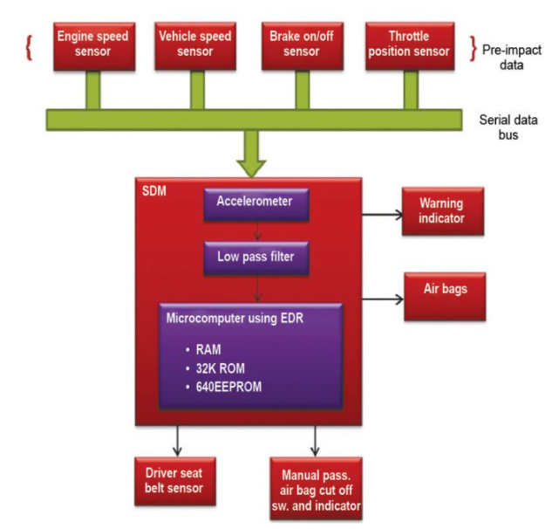

The airbag system is an important safety device that provides extra protection against head-on crash for the passengers, by giving a soft surface to land on. This system works on commands from the airbag control unit, which has a microcontroller. The controller gets power from the battery.

If the collision sensor detects an accident, a signal is sent to the airbag control unit and it is processed by the airbag control unit to determine severity of the impact. If airbag deployment is necessary, the airbag control unit sends a signal to initiate airbag inflators. Inflators are activated through an igniter, causing a chemical reaction that emits nitrogen gas, resulting in the deployment of the airbag cushion.

An occupant detection system is used to determine if a person is seated in the passenger seat and if he or she is of adequate size to be protected in the event of deployment of the passenger seat airbag. It measures the weight of the passenger to determine if the corresponding airbag should deploy.

In 2012-13, a new type of occupant detection system called electrostatic capacitance sensor was implemented. This system does not use weight to determine whether to turn the occupant detection system on or off.

Electrostatic capacitance represents a material’s capability of storing an electrical charge. When someone is seated or when something is placed on the passenger seat, there is a change to that capacitance value. Change in capacitance value is what electrostatic capacitance sensor occupant detection system uses to determine whether the passenger seat airbag will be on or off.

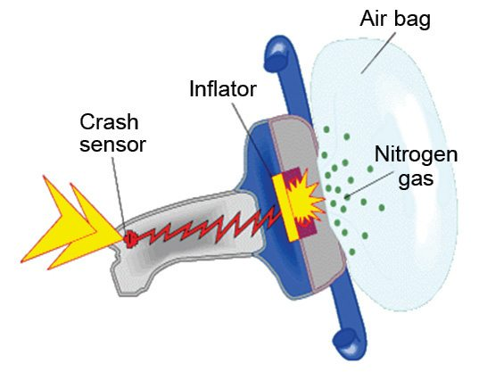

**Testing-**

As a basic principle, work on the airbag system must only be performed by specialist, appropriately trained professionals.

All legal and manufacturer-specific regulations must be followed. The same applies to the disposal of any deployed or old airbags. It is advisable to train all workshop employees if possible, because many tasks which are not necessarily related directly to the airbag still require the airbag or seat belt tensioner to be removed. One example of this would be work on the instrument cluster.

As is the case for diagnostics and troubleshooting in other systems, the first step is to conduct a visual inspection. In the process, check all visible components of the airbag system for damage and to ensure the plug contacts are correctly connected. One common fault cause is a poor plug connection to the seat belt tensioners or side airbags in the area of the front seats. As the seats are moved forward and back the plug connections become loose, which causes contact resistance